EXPERIMENT 7A

DATA VISUALIZATION USING TABLEAU – Sample Dataset

Aim:
To connect, analyze, visualize, and create interactive dashboards using Tableau for effective business intelligence and data analytics.
Sample Dataset:
Student Performance Dataset
Student | Department | Marks
Arun | CSE | 85
Bala | IT | 78
Divya | CSE | 95
Priya | AIDS | 90
Ravi | IT | 72
Karthik | AIDS | 88

Algorithm 1:
Connecting Data Source
Step 1 Open Tableau Desktop
Step 2 Select Connect
Step 3 Choose Excel File
Step 4 Browse Dataset
Step 5 Open Dataset
Step 6 Verify Imported Data
Algorithm 2:
Creating Worksheet
Step 1 Open Sheet 1
Step 2 Drag Department to Columns
Step 3 Drag Marks to Rows
Step 4 Select Visualization
Step 5 Analyze Results

Output:
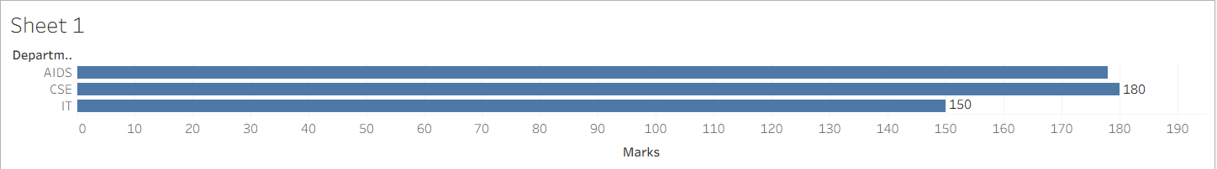

Algorithm 3:
Bar Chart Creation
Step 1 Drag Student → Columns
Step 2 Drag Marks → Rows
Step 3 Select Bar Chart
Step 4 Apply Labels
Step 5 Format Visualization

Output:


Algorithm 4:
Pie Chart Creation
Step 1 Drag Department
Step 2 Drag Marks
Step 3 Select Pie Chart
Step 4 Show Labels
Step 5 Analyze Distribution

Output:
Department-wise Marks Contribution
Contribution of departments to total marks.
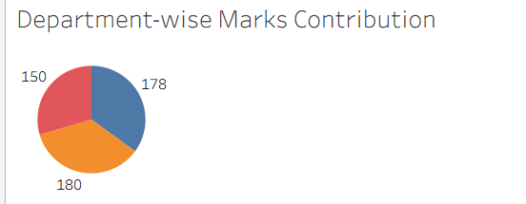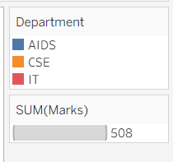

Algorithm 5:
Line Chart Creation
Step 1 Drag Student
Step 2 Drag Marks
Step 3 Select Line Chart
Step 4 Apply Formatting

Output:
Student Performance Trend
Marks trend among students.
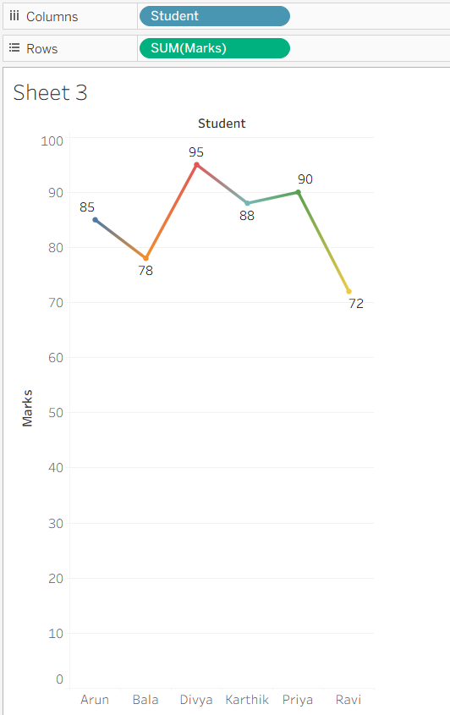

Algorithm 6:
Creating Calculated Field
Objective
Calculate Percentage
Marks Formula (Marks / 100) * 100
Procedure
Analysis → Create Calculated Field
Name: Percentage
Formula: [Marks]

Output:
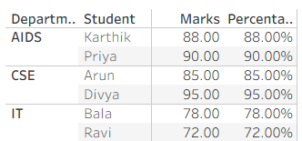

Algorithm 7:
Applying Filters
Step 1 Drag Department to Filters
Step 2 Select Department
Step 3 Apply Filter
Step 4 Observe Updated Charts

Algorithm 8:
Creating Parameter
Step 1 Create Parameter
Step 2 Specify Minimum Marks
Step 3 Apply Parameter
Step 4 Display Matching Records

Output:
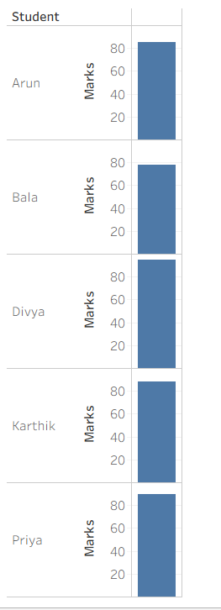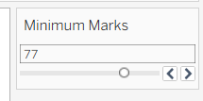

Algorithm 9:
Dashboard Creation
Step 1 Create Multiple Worksheets
Step 2 Select Dashboard
Step 3 Drag Worksheets
Step 4 Arrange Components
Step 5 Add Filters
Step 6 Save Dashboard

Output:
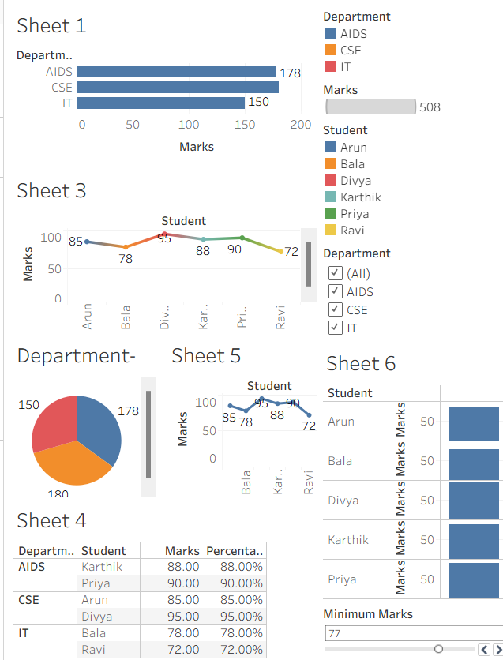

Result:
Thus, Tableau was used successfully to connect datasets, create worksheets, apply filters and parameters, generate visualizations, build dashboards, and create stories for business intelligence and analytical decision-making.

